NAPLAN ONLINE 2023

The National Assessment Program – Literacy and Numeracy (NAPLAN) is a point in time assessment of literacy and numeracy skills that are essential for every child to progress through school and life. Students in Years 3, 5, 7 and 9 participate in the annual NAPLAN tests in writing, reading, conventions of language (spelling, grammar and punctuation) and numeracy.

Our school will be participating in NAPLAN Online between 15 and 27 March 2023.

In preparation for NAPLAN Online, our school will also participate in practice tests before the official NAPLAN testing window. The practice tests are a trial-run and key preparation activity for NAPLAN Online in March. It is not an assessment of student ability and the tests will not be marked.

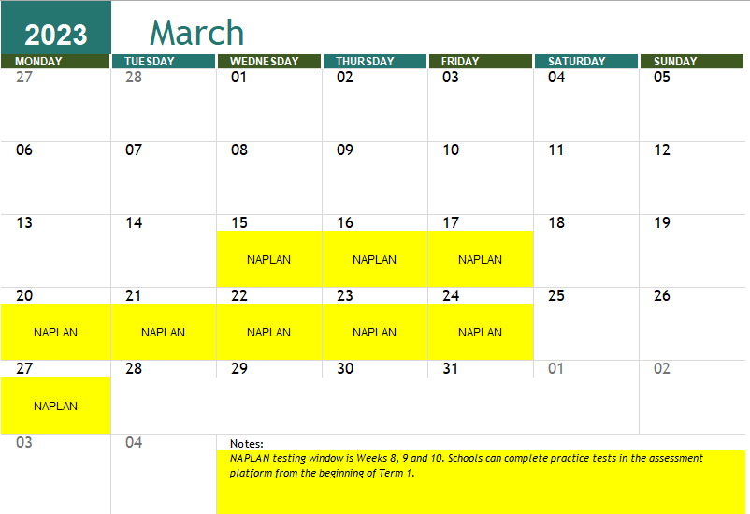
Excessive preparation for NAPLAN Online is not recommended. Students can use the public demonstration site (https://www.nap.edu.au/online-assessment/public-demonstration-site) to familiarise themselves with the types of questions and tools available in the NAPLAN Online tests.

If you have any questions about NAPLAN Online, please contact NAPLAN Coordinator, Mr Scott Parrey on 4933 7933.

A schedule for NAPLAN Online Tests will be discussed with students at Year Meetings and published to our school community two weeks prior to the testing window.

Paula Graham  Ms Paula Graham  Principal | Scott Parrey  Mr Scott Parrey  NAPLAN Coordinator | Toni Williams  Ms Toni Williams  NAPLAN Coordinator (Disability Provisions)

